Monthly Performance Report – May 2025
Kestrel Ridge Wind Farm (75.6 MW)
David Chen · 09 June 2025 · KR-OPS-RPT-2025-05

1. Summary
Kestrel Ridge generated 14.2 GWh in May 2025, 0.7 % below the P50 budget of 14.3 GWh. Availability of 97.2 % met the contract target of 97.0 %. Mean hub-height wind speed of 7.4 m/s was close to the long-term mean (7.3 m/s). Compared with May 2024 (12.9 GWh), output was up 1.3 GWh.
The first annual service campaign started on 12 May (3 turbines completed in May).

2. Production and key figures
KPI | May 2025 | Budget / target | YTD 2025 | YTD budget
Net generation (GWh) | 14.2 | 14.3 | 94.5 | 99.0
Time-based availability | 97.2 % | 97.0 % | 97.3 % | 97.0 %
Capacity factor | 25.2 % | 25.4 % | 34.5 % | –
Mean wind speed at hub height (m/s) | 7.4 | 7.3 | – | –
Source: Kestrel Ridge SCADA, revenue meter at 132 kV point of connection. Budget = P50 (2024 post-construction yield assessment).
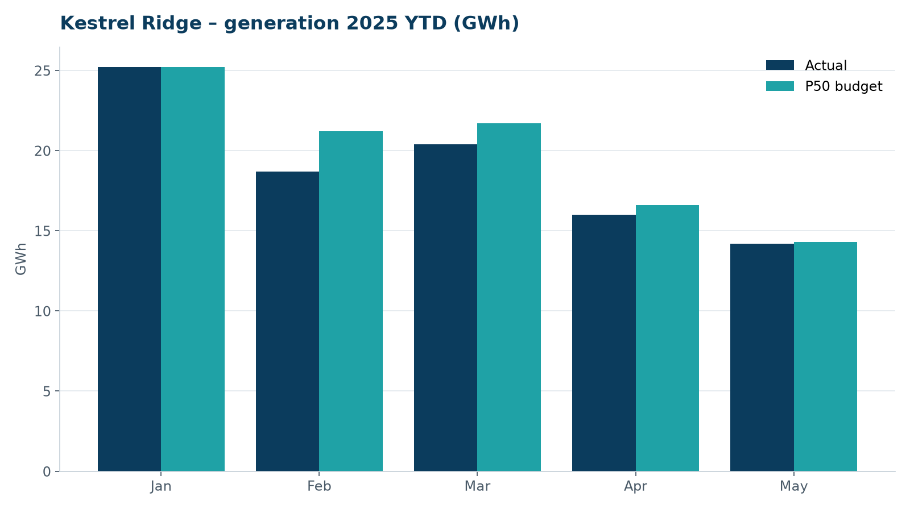
Monthly generation vs. P50 budget, 2025 year to date

3. Availability and downtime
Total turbine downtime attributable to the contractor amounted to 42 turbine-hours for the top events listed below. No grid or force majeure exclusions were claimed this month.
Turbine | Event | Downtime (h)
T-15 | pitch motor encoder fault on blade A | 22
T-13 | anemometer heater failure – sensor replaced | 9
T-07 | high-voltage transformer gas relay alarm (inspected, no fault found) | 7
T-15 | service lift fault – lift locked out, turbine stopped for rescue cover | 4
Top downtime events of the month (SCADA event log, reviewed with Highline Wind Services).

4. Maintenance
- Annual service: 3 turbines completed this month.
- 12 corrective work orders closed, 6 still open at month end.
- Gearbox oil samples taken on six turbines as per the quarterly rota; results within limits.

5. Health, safety and environment
Indicator | Month
Hours worked on site (Highline + Weyland) | 3,964
Lost time injuries | 0
First aid cases | 0
Near misses reported | 1
Safety observations | 13
Environmental incidents | 0

No environmental incidents. Bird carcass searches were carried out on schedule (fortnightly, all turbines).

6. Outlook
Next month's focus: closing open corrective work orders and preparing the quarterly O&M review with Highline Wind Services.
Prepared by Sara Lindgren (Performance Analyst); reviewed by Ben Okoye (Site Manager) and David Chen (Asset Operations Manager).

